**Ideation Phase**

**Define the Problem Statements**

|  |  |
| --- | --- |
| Date | 26.06.2025 |
| Team ID | SWUID20250170870 |
| Project Name | Freelancing Application Mern |
| Maximum Marks | 2 Marks |

**Customer Problem Statement Template:**

To define the core problems freelancers face while searching for jobs online , and use those insights to guide the development of SB works . Freelancing Application

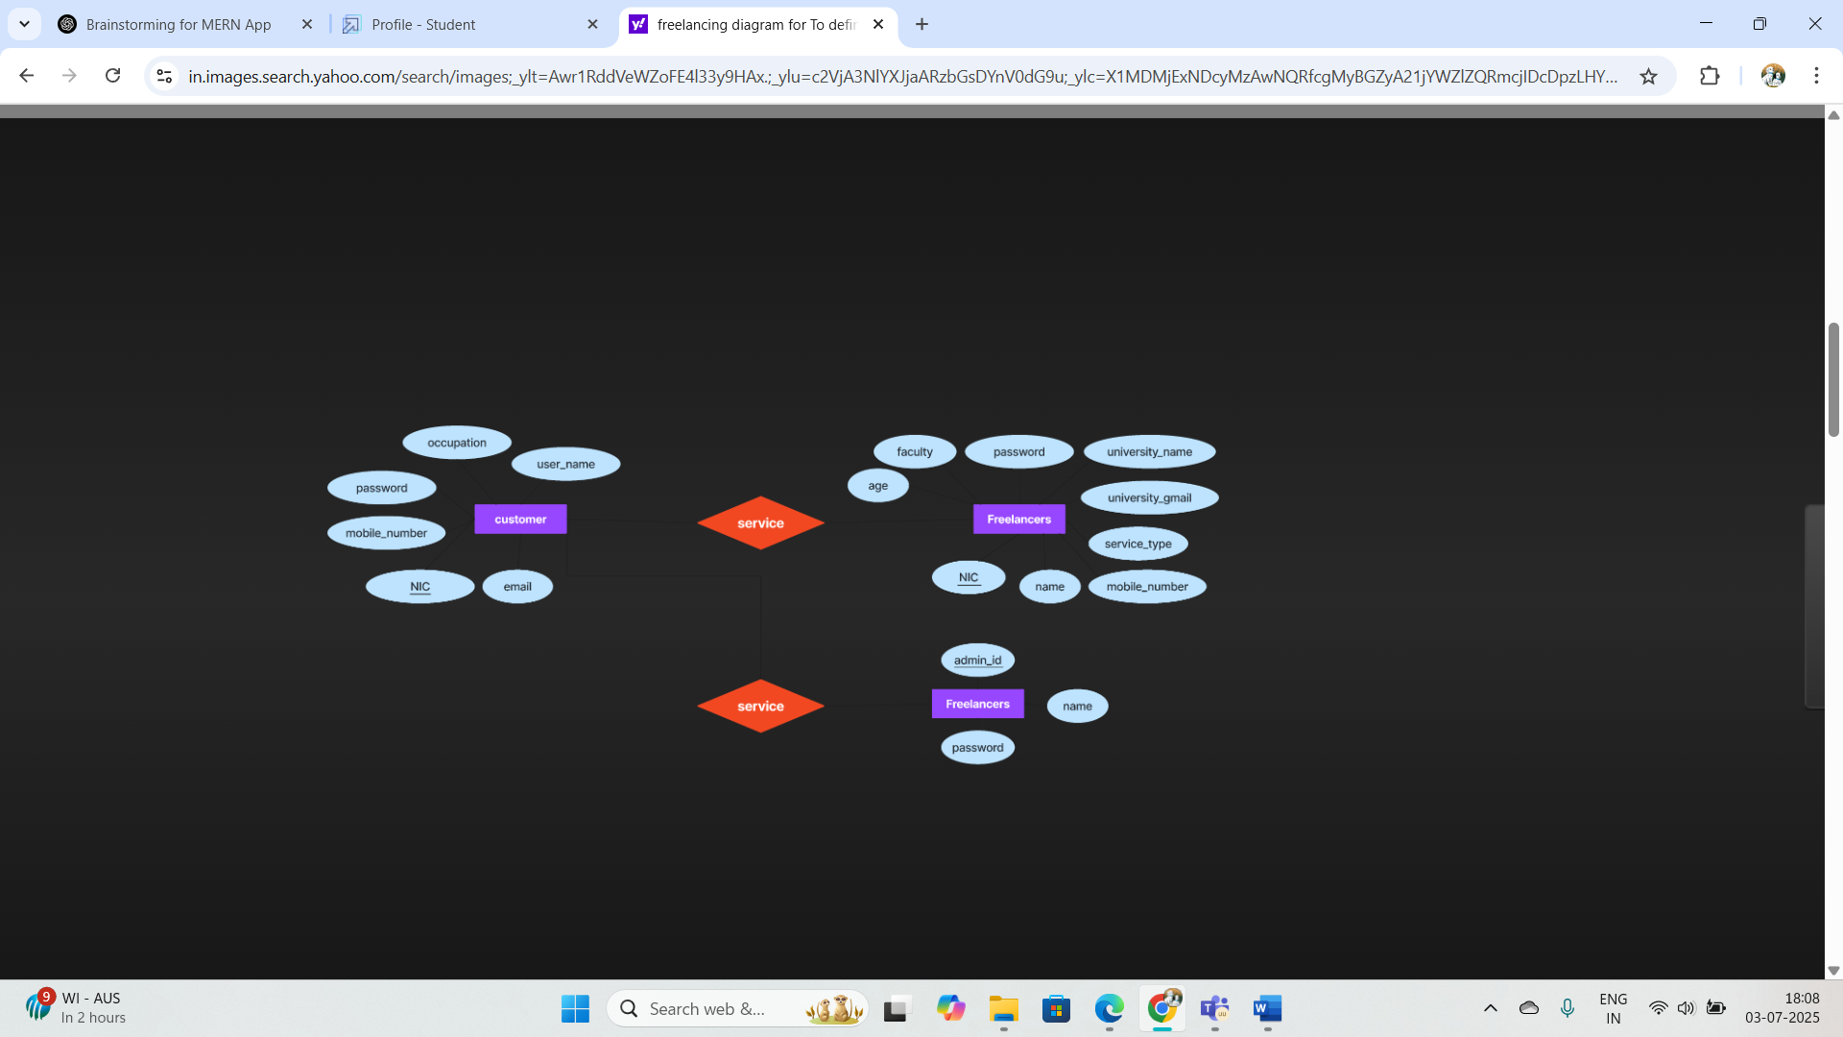

|  |  |  |  |  |  |
| --- | --- | --- | --- | --- | --- |
| **Problem Statement (PS)** | **I am (Customer)** | **I’m trying to** | **But** | **Because** | **Which makes me feel** |
| PS-1 | Client looking for trustworthy freelancers | Post projects and find reliable professionals easily | Most platforms don’t verify freelancer credentials properly | I have to spend extra time checking backgrounds manually. | Overwhelmed and frustrated |
| PS-2 | New freelancer without many reviews | Win my first few projects. | Clients usually pick freelancers with higher ratings | I don’t get a chance to prove my skills | Discouraged and stuck |
| PS-3 | Freelance developer | Find steady, fairly paid projects | Competition is very high and clients choose low bids | Many clients care only about price, not quality | Demotivated and undervalued |
| PS-4 | Returning client | Manage my ongoing projects in one place | Platforms lack clear project tracking and communication | I lose track of progress and updates easily | Confused and dissatisfied |
| PS-5 | |  | | --- | |  |  |  | | --- | | Admin/Platform Owner | | Keep the platform safe and fair | Manual moderation is time-consuming | I need better tools to detect issues and manage disputes | Stressed and overworked |